**DAILY ONLINE ACTIVITIES SUMMARY**

|  |  |  |  |  |  |  |  |  |
| --- | --- | --- | --- | --- | --- | --- | --- | --- |
| **Date:** | **18/08/2020** | | | | | **Name:** | **NAIPUNYA VINOD NAIK** | |
| **Sem & Sec** | **IV SEM & A SECTION** | | | | | **USN:** | **4AL18CS050** | |
| **Online Test Summary** | | | | | | | | |
| **Subject** | | **NO INTERNALS CONDUCTED** | | | | | | |
| **Max. Marks** | | **-------------** | | **Score** | | | **------------------** | |
| **Certification Course Summary** | | | | | | | | |
| **Course** | 1)GOOGLE DATA STUDIO A-Z FOR DATA VISUALIZATION AND DASHBOARDS | | | | | | | |
| **Certificate Provider** | | | **UDEMY** | | **Duration** | | | **4 HRS** |
| **Coding Challenges** | | | | | | | | |
| **Problem Statement:1)** Write a C Program to generate first N Magic Numbers. | | | | | | | | |
| **Status:- EXECUTED** | | | | | | | | |
| **Uploaded the report in Github** | | | | | **YES** | | | |
| **If yes Repository name** | | | | | <https://github.com/naipunya-naik/lockdown-coding/blob/master/C%20CODING/magic%20number_18-06-2020.c> | | | |
| **Uploaded the report in slack** | | | | | **YES** | | | |

Online Test Details: (Attach the snapshot and briefly write the report for the same)

NO INTERNALS CONDUCTED

Certification Course Details: (Attach the snapshot and briefly write the report for the same)

CERTIFICATION COURSE NAME:- GOOGLE DATA STUDIO A-Z FOR DATA VISUALIZATION AND DASHBOARDS



TODAY I COMPLETED ANOTHER CERTIFICATION COURSE GOOGLE DATA STUDIO A-Z FOR DATA VISUALIZATION AND DASHBOARDS.

Coding Challenges Details: (Attach the snapshot and briefly write the report for the same).

PROBLEM STATEMENT:- Write a C Program to generate first N Magic Numbers.

Top of Form

Bottom of Form

|  |
| --- |
| A magic number is defined as a number which can be expressed as a power of 5 or sum of unique powers of 5. First few magic numbers are 5, 25, 30(5 + 25), 125, 130(125 + 5), …. Input: n = 1 Output: 5  Input: n = 2 Output: 5 25  Input: n = 3 Output: 5 25 30  Input: n = 8 Output: 5 25 30 125 130 150 155 625  Hint: The magic numbers can be represented as 001, 010, 011, 100, 101, 110 etc, where 001 is 0*pow(5,3) + 0*pow(5,2) + 1*pow(5,1). So basically, we need to add powers of 5 for each bit set in given integer n. If n = 1; binary representation of 1 = 0001 Magic Number is: 0 * pow(5,4) + 0 * pow(5, 3) + 0 * pow(5, 2) + 1 * pow(5, 1) = 5  If n = 6; Binary representation of 6 is 0110 6th Magic Number is: 0 * pow(5, 4) + 1 * pow(5, 3) + 1 * pow(5, 2) + 0 * pow(5, 1) = 0 + 125 + 25 + 0 = 150  Logic:  Read n for(i = 0 to n) { Display ith magic number } |

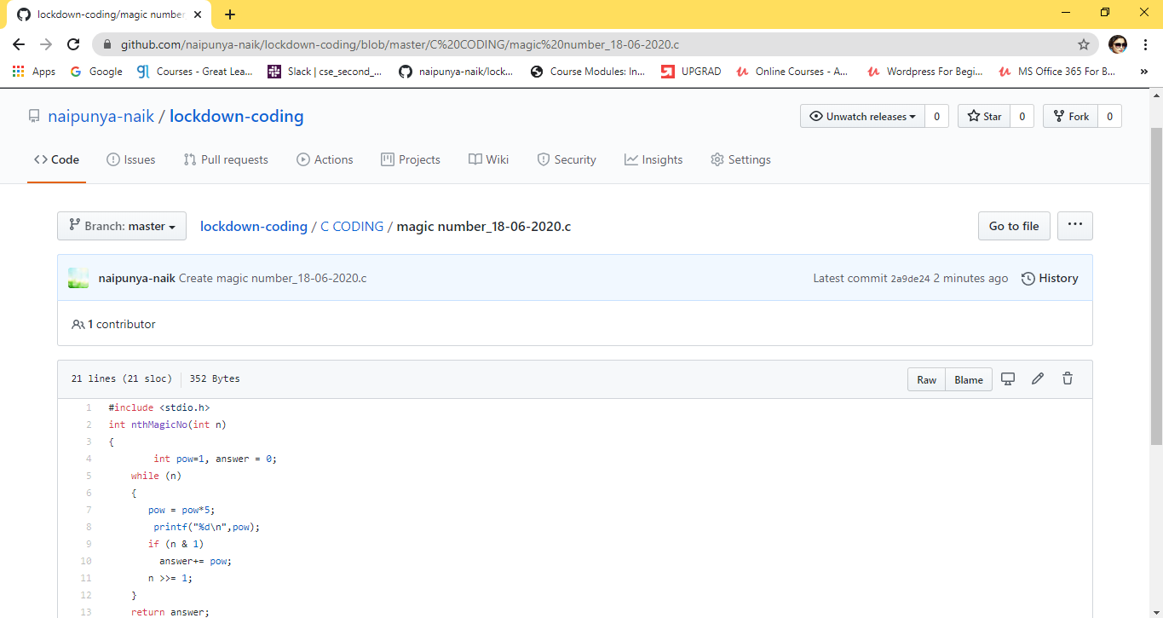

GITHUB REPOSITORY LINK:-

<https://github.com/naipunya-naik/lockdown-coding/blob/master/C%20CODING/magic%20number_18-06-2020.c>